Bank loan Analysis-- Python Project Report
1) Data loading : import pandas as pd, For advance numerical aggregation : import numpy as np, and for bulding the charts used import matplotlib.pyplot as plt ,seaborn as sns,plotly.express as px and to get the correct warnings at the time of arrors I have used import warnings.
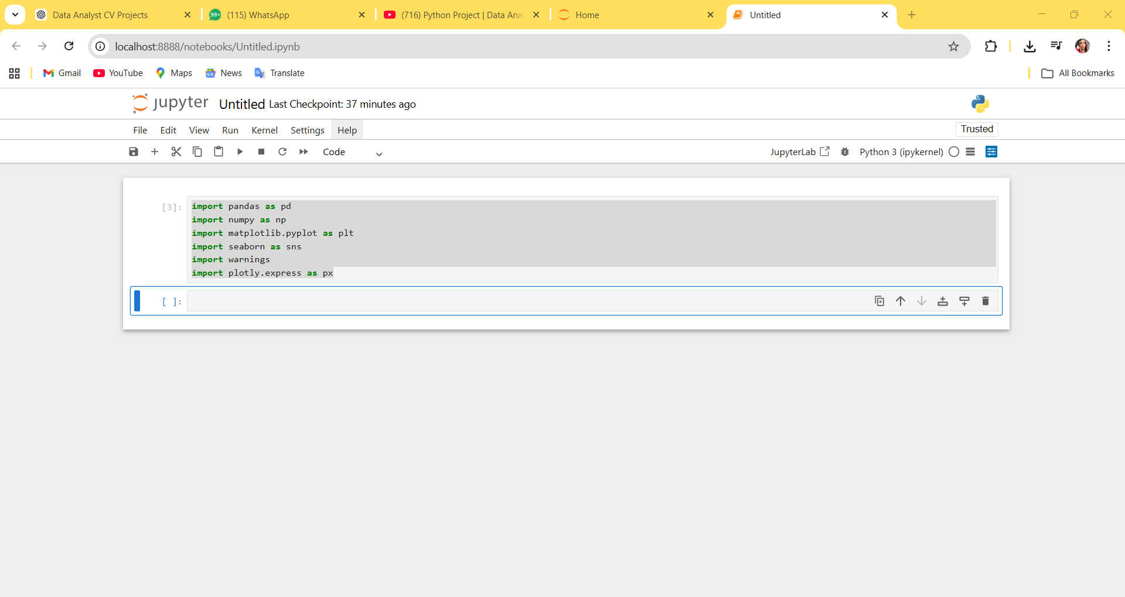

2) Imported the excel file (Financial_loan) from local system to jupyter notebook
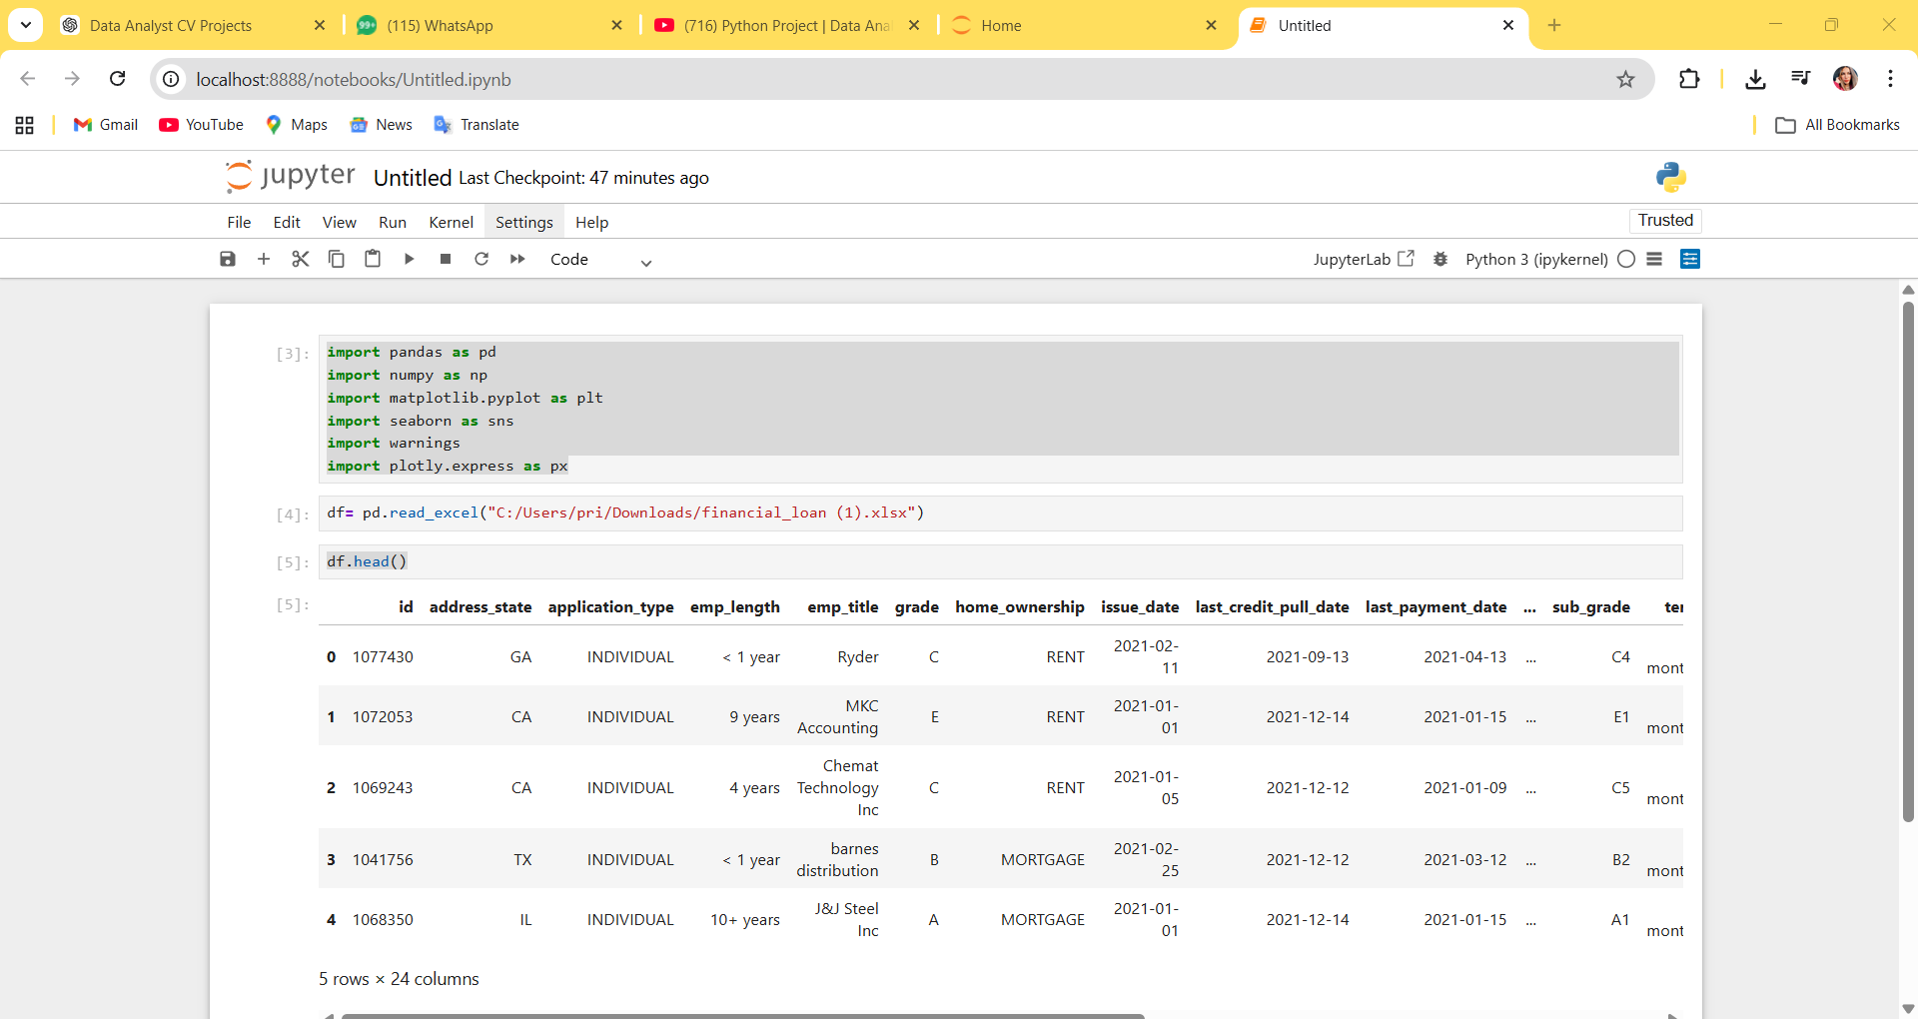

3) Metadata of Data
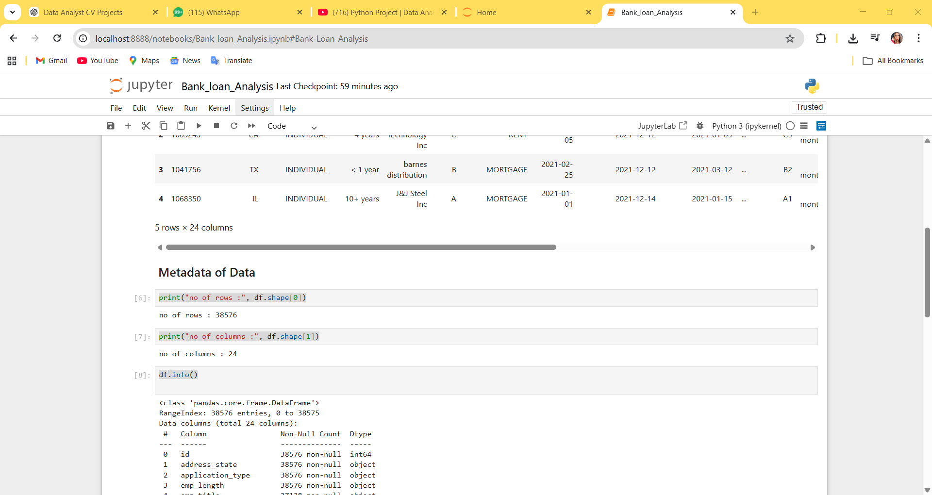

4) total Loan Applications And MTD total Loan Applications
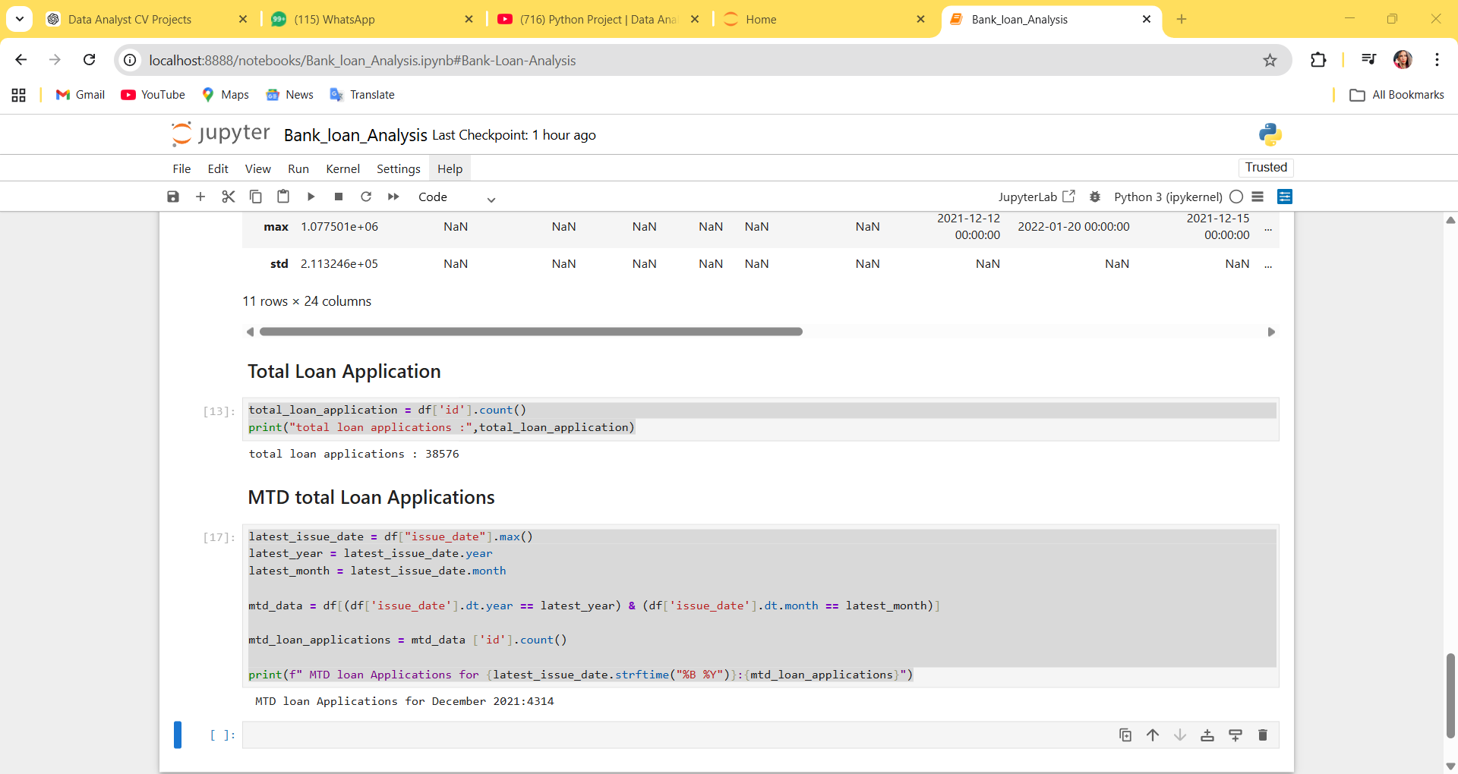

5) Total Funded Amount and MTD Total Funded Amount in Millions
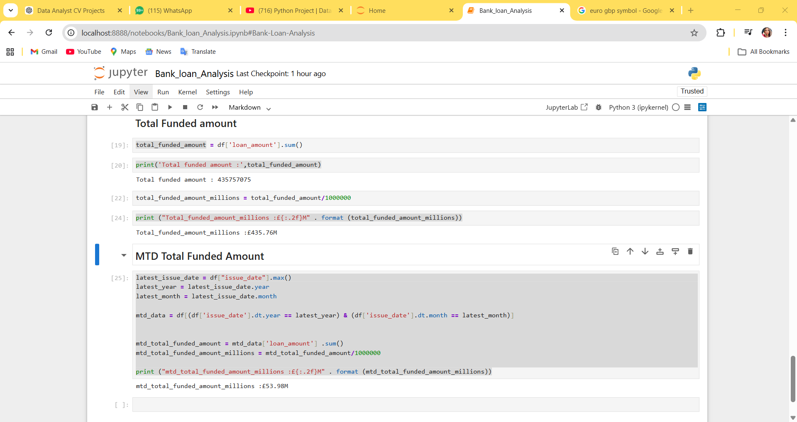

6) Total Amount Received and MTD Total Amount Received in Millions
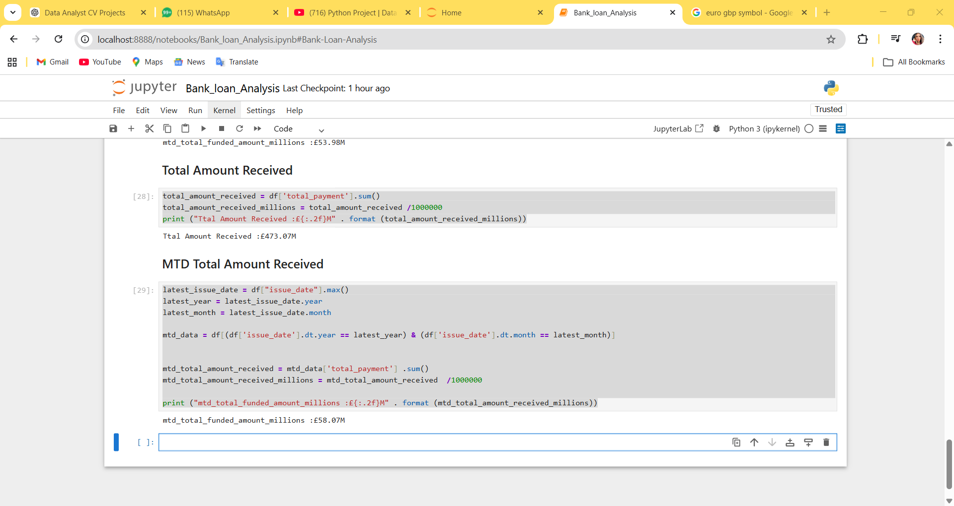
7) Average Interest Rate and Debt to Income ration (DTI)
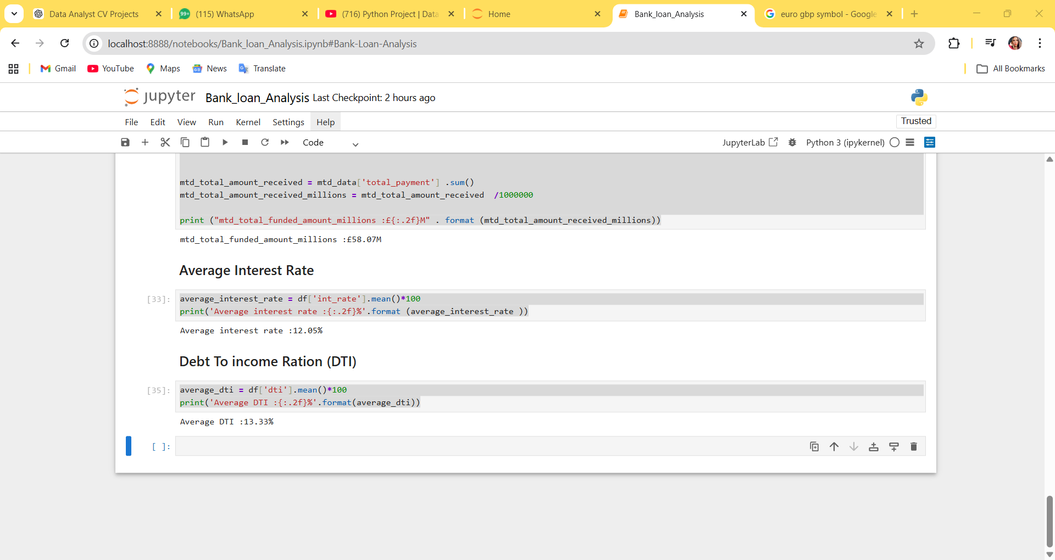

8) Good Loan Metrics
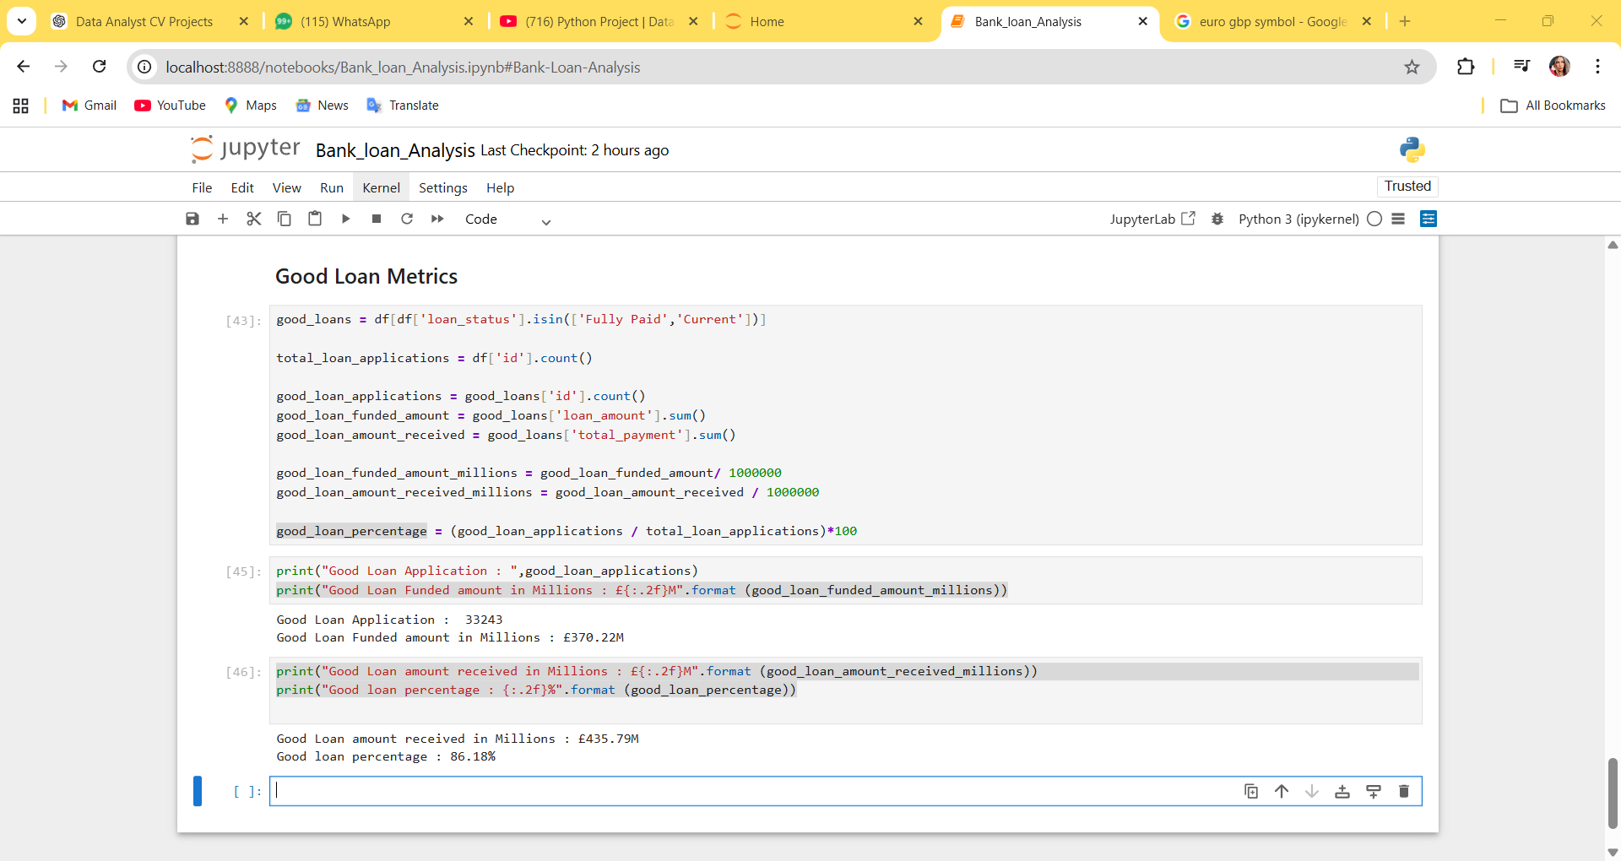

9) Bad Loan metrics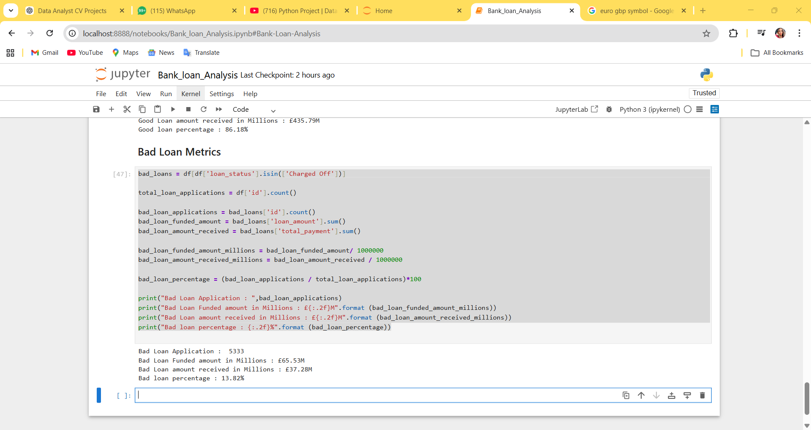

10) Monthly trend By issue Date for Total amount funded (this syntax will help in making chart in the jupyter notebook)

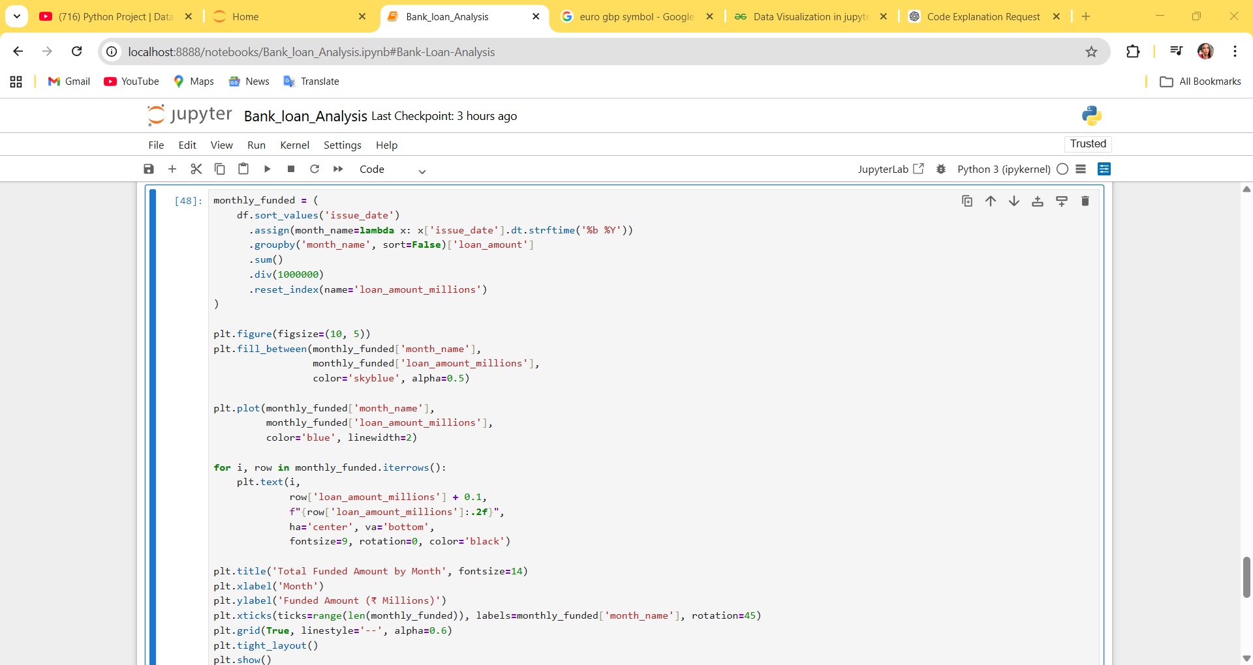

11) Monthly trend By issue Date for Total amount Received (this syntax will help in making chart in the jupyter notebook)
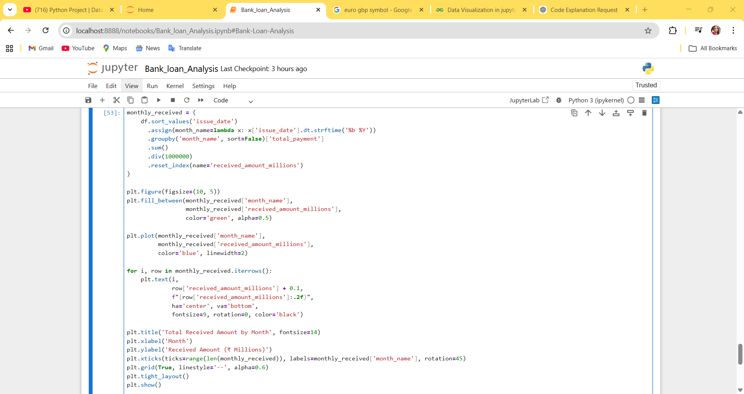

12) Monthly trend By issue Date for Total Loan applications (this syntax will help in making bar chart in the jupyter notebook)

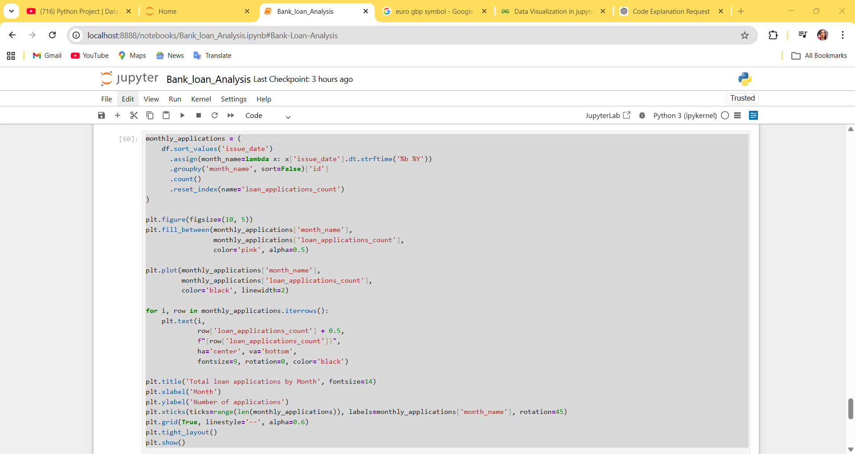

13) Regional Analysis by State for Total Funded amount (the syntax in the picture will help in making a column chart)
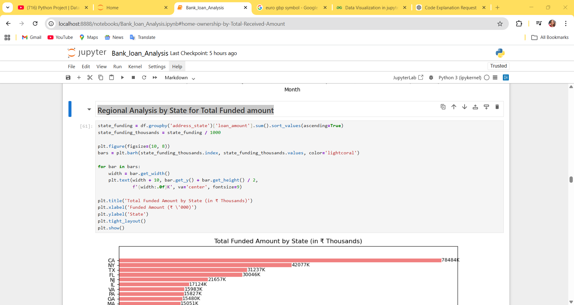

14) Loan Term analysis by Total Funded amount (the syntax in the picture will help in making a donut chart)

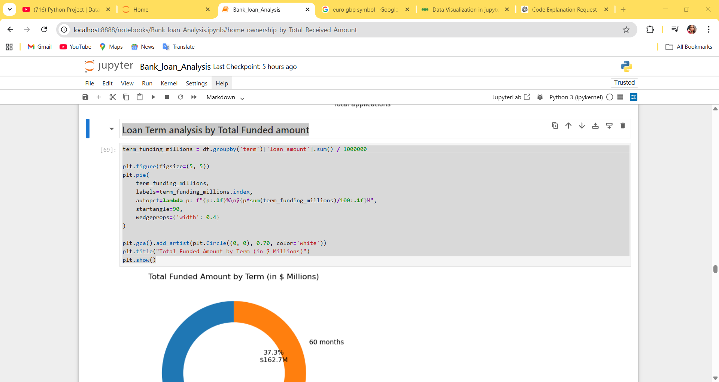

15) Employee Length analysis by Total Funded Amount (The snippet in the picture will help in making column bar chart)
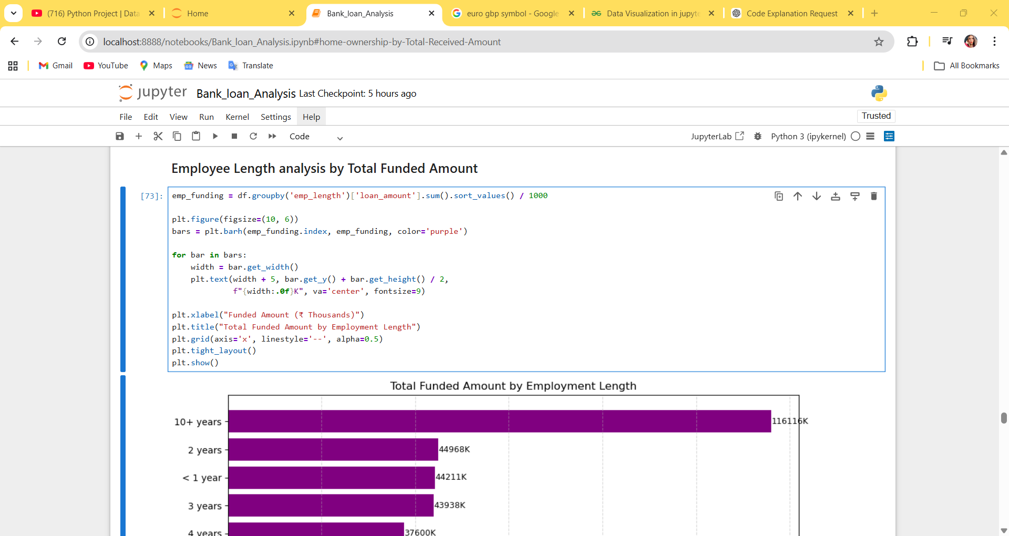

16) Loan Purpose by Total Funded Amount (The snippet in the picture will help in making a bar chart)
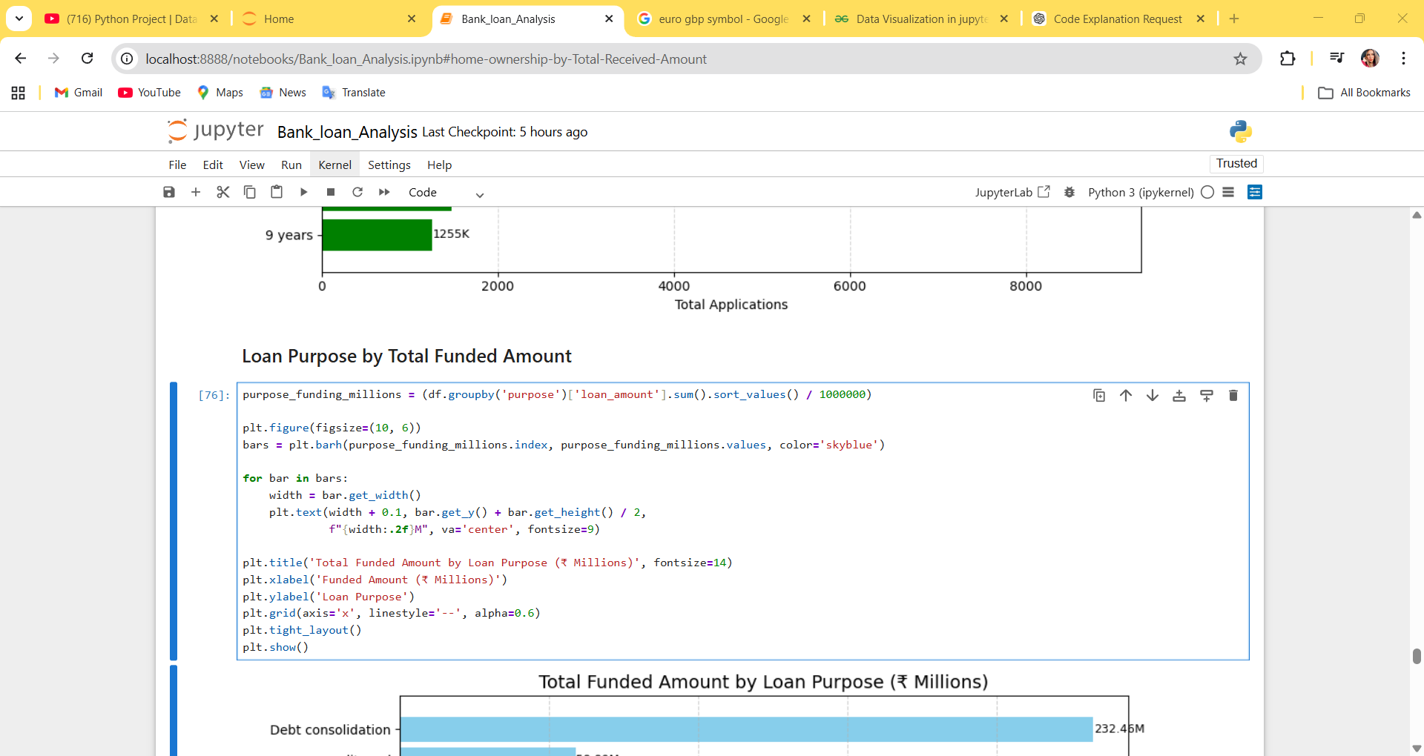

17) Home ownership by total funded Amount (The syntax in the picture will help in making treemap chart)

